NAME : ADVITEEYA SHRAV

Q) Write a Program to find Biggest of given 2 Numbers from the Command Prompt?

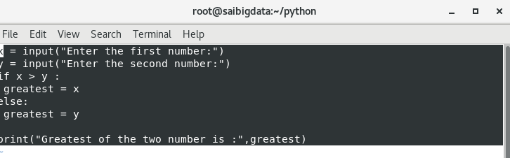

OUTPUT:

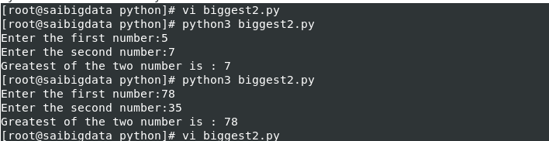

Q) Write a Program to find Biggest of given 3 Numbers from the Command Prompt?

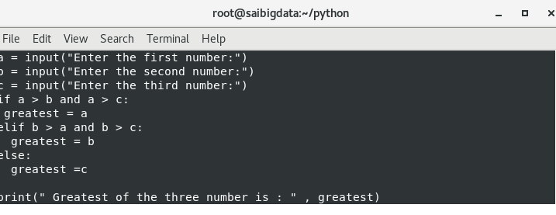

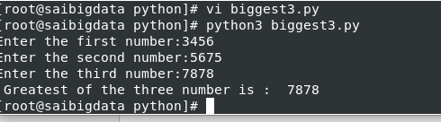

Q) Write a program to find smallest of given 2 numbers?

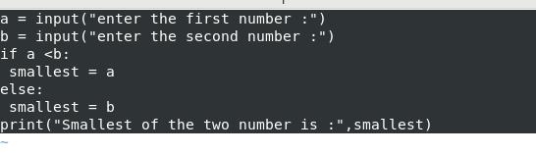

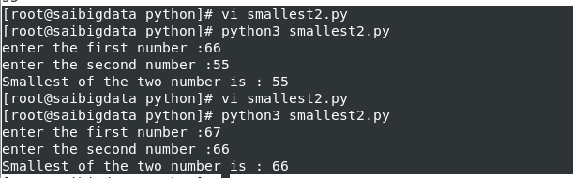

Q) Write a program to find smallest of given 3 numbers?

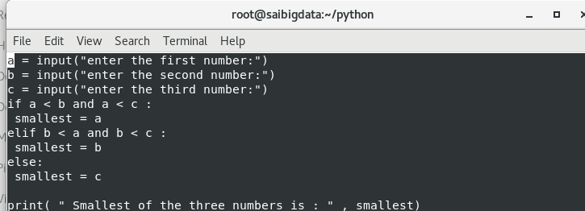

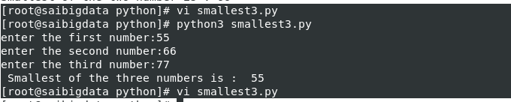

Q) Write a program to check whether the given number is even or odd?

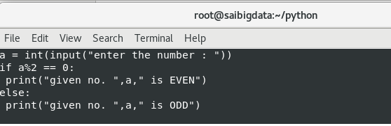

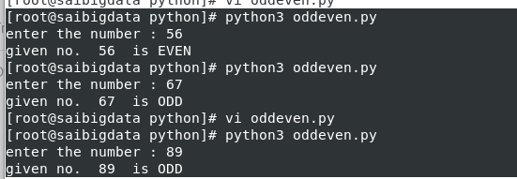

Q) Write a Program to Check whether the given Number is in between 1 and 100?

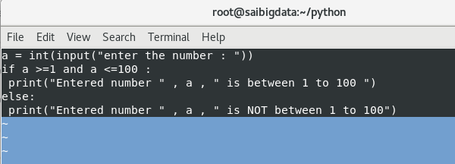

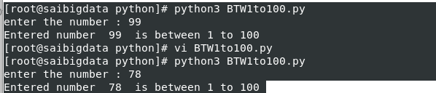

Q) Write a Program to take a Single Digit Number from the Key Board and Print

is Value in English Word?

